Snowfan in 2023 Manufacturing world exhibition
in Osaka, Japan

Snowfan has joined this Japan top exhibition for the first time and introduced ourselves to Japan market. It is a great opportunity to show our company and products, meet customers and suppliers, and explore different industries and technologies. Here are pictures for our activities in this brilliant show.


Meeting with local visitors.

Chatting with visitors interested in our products.

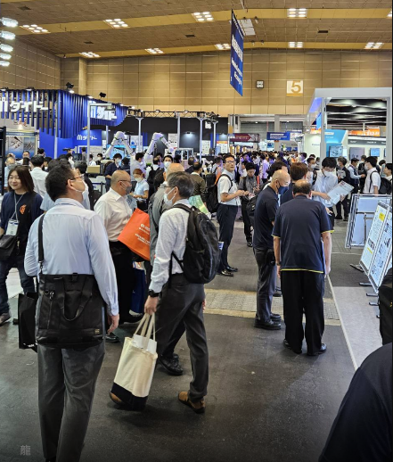
Hall with crowded visitors.
--Click the following link for video showing the exhibition from the host :
https://youtu.be/lfKZ77OKzsQ

--Visitor analysis from the host :



